A000-Eur-Danube Rider Votive Plaque-Box Gable Roof-Lower Moesia-Lead-3rd c CE

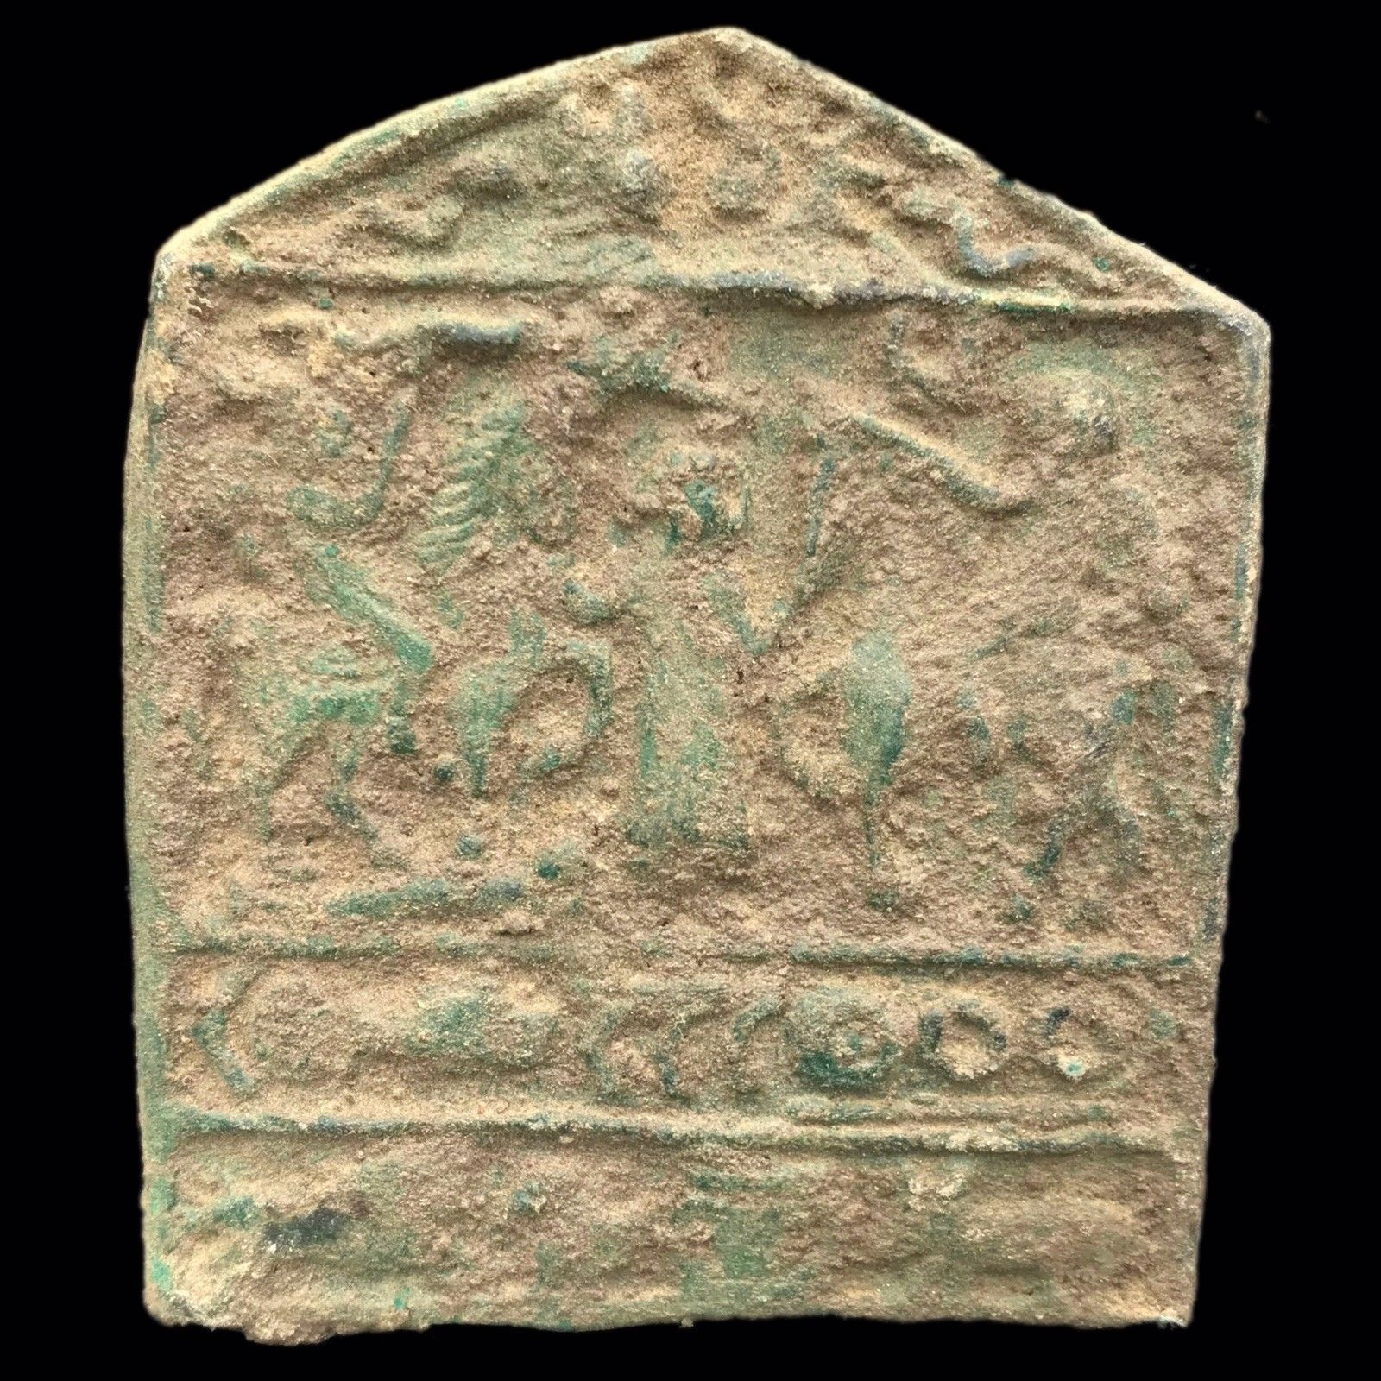

**Formal Label:** Eur-Danube Rider Votive Plaque-Box Gable Roof-Lower Moesia-Lead-3rd c CE

**Display Description:**

This cast-lead plaque appears as a cut-away model of a box-gabled cultic sanctuary or aedicula of the Danube Rider. It is similar to three examples. It is comparable to the plaque E 02-002 detailed in Ertl (1996, Tafel L) from Moesia Inferior, Nikopol, Bulgaria now in the Ghighen Museum.



Nikopol, Ukraine, after [https://www.google.com/maps/place/47°34'00.0"N+34°24'00.0"E](https://www.google.com/maps/place/47°34'00.0%22N+34°24'00.0%22E).

Orlea, Romania after https://www.google.com/maps/place/Orlea+237305,+Romania/@47.1293954,20.681087,1374684m

Another is from an undisclosed Dacian site dating to the 3rd c CE (by coins and pottery) found in 1958 (Tudor 1960) and another from a site at Orlea (6 km w of SVCIDAVA) (Tudor 1969). The last two are in the Bucarest Museum.

This present example has four registers separated by plain bands that detail a complex iconography of divine figures and symbols associated with Thracian, Dacian and Roman beliefs of the Lower Danube region.

**First Register.** In the first register in the center of the tympanum are busts of Sol, on the right with a radiate crown, and Luna on the left as a front-facing orb held within a footed pedestal. These busts are bordered by two approaching snakes, probably the non-venomous pan-Mediterranean Aesculapian snake (*Zamenis longissimus*).

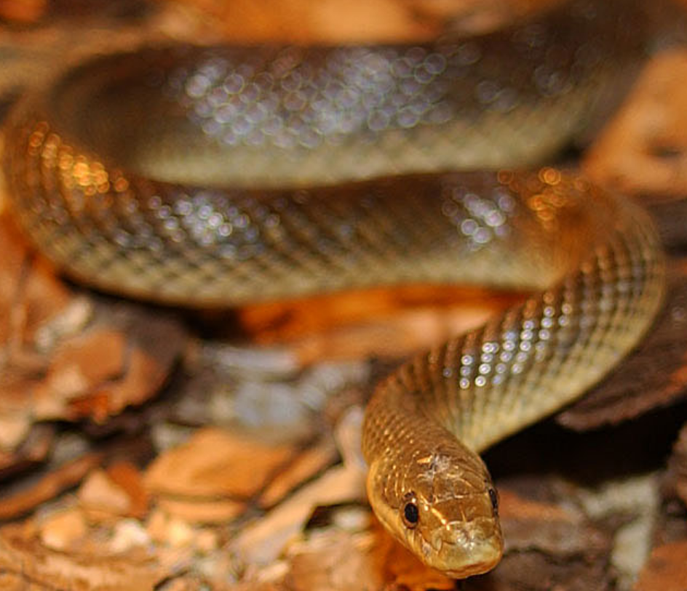 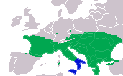

Left: Aesculapian snake (*Zamenis longissimus*) <http://www.museum.nantes.fr/pages/07-actioneducative/banque_herpeto.htm> © Patrick JEAN / muséum d'histoire naturelle de Nantes".

Right: Range of *Zamenis longissimus*, European variety (green) and Italian variety (blue).After <https://en.wikipedia.org/wiki/Aesculapian_snake#/media/File:Zamenis_longissimus_dis.png>

Aesculapian snakes had been used by the 5th c BCE Greek physician Asklēpiós (Greek: Ἀσκληπιός; Latin: Aesculapius; English: Asclepius). During the Peloponnesian Wars, which were fought between Athens and Sparta in two stages, from c. 460 to 446 BCE and from 431 to 404 BCE, infection, disease and wounds were rampant. Asklēpiós and his five daughters gained lasting fame in their treatment of the sick and wounded during their lifetimes at the most ancient Aesclepieion or hospital, the one at [Trikala](https://en.wikipedia.org/wiki/Trikala) according to geographer-historian Strabo (64 or 63 BCE – c 24 CE) (Karapanou S. 1999; Kastriotis P. 1903; Tziafalia A. 1998). As the fame of Asklēpiós spread, an Aesclepieion was built in the 4th c BCE at [Epidaurus](https://en.wikipedia.org/wiki/Epidaurus) in north-eastern [Peloponnese](https://en.wikipedia.org/wiki/Peloponnese) (Edelstein and E#delstein 1998: 243). The daughters had specific rôles in healing: Panacea (universal health); [Hygieia](https://en.wikipedia.org/wiki/Hygieia) (sanitation); [Iaso](https://en.wikipedia.org/wiki/Iaso) (rehabilitation); [Aceso](https://en.wikipedia.org/wiki/Aceso) (healing); [Aglæa/Ægle](https://en.wikipedia.org/wiki/Aglaea) (personal grooming).



Aesculapian snake and crutch used as an emblem for Aesculapius. <https://commons.wikimedia.org/w/index.php?curid=2243460>. By Ddcfnc, CC BY-SA 3.0,

Aesculapian snake and crutch used as an emblem for Aesculapius. Note the prominence of the forked tongue of the snake that was responsible for removing bacteria frim infections and wounds. The crutch is meant to signify the end of disabling disease. By Ddcfnc, CC BY-SA 3.0, https://commons.wikimedia.org/w/index.php?curid=2243460

Asklēpiós’ renowned healing remedy was the use of the Aesculapian snake (*Zamenis longissimus*). In Classical Greece non-poisonous snakes were considered sacred beings of healing because they were used to lick the wounds and infections of patients free of bacteria much like the use of inserting maggots into a wound or infection to consume bacteria. Asklēpiós developed this technique for use in his Aesclepieion. His emblem, henceforth, became a crutch entwined with a single snake (as opposed to the double snakes encircling the caduceus of Hippocrates). Note the prominence of the forked tongue of the snake in the woodcut of the Aesculapian snake and crutch that was responsible for removing bacteria frim infections and wounds. The crutch is meant to signify the end of disabling disease.

The tradition of how the cult of Aesculapius was brought to Rome’s Tiberine Island is intimately associated with the Sibylline Books, an ancient collection of sanctions that had been articulated by the Hellespontine Sibyl and preserved in the temple of Apollo at Gergis on Mount Ida in the Troad. If advice were asked Sibyl’s voice would issue through a small opening in the floor of the Temple of Apollo where her priestesses translated the cryptic answers into an understandable, but ambiguous authorization. They would then bring these advisements to clients in front of the temple. The ambiguity of the oracles safeguarded the priests of any disproof, because the clients included kings and elders had to explain all their fears, hopes and plans prior to consulting the Sibyl.

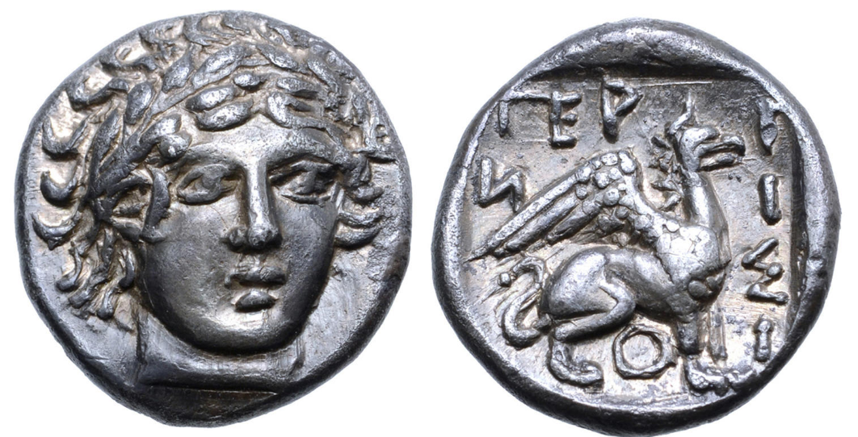

Laureate head of Apollo/Sibyl on the reverse of a bronze coin struck c 420-400 BCE at the Greek town of Gergis in Troad, Asia Minor, AR Hemidrachm (?). Obverse has a Griffin/Sphinx seated to right, ΓEPΓIΣIOИ around; all within incuse square. CNG 102, lot 398 (same dies), otherwise unpublished. 1.94g, 12mm, 6h.This memorial portrait suggests that Apollo/Sibyl was indeed a real person. Ex Triton XX, 10 January 2017, lot 249. [Roma Numismatics Ltd](https://www.numisbids.com/sales/hosted/firminformation.php?fid=71&sid=2451).

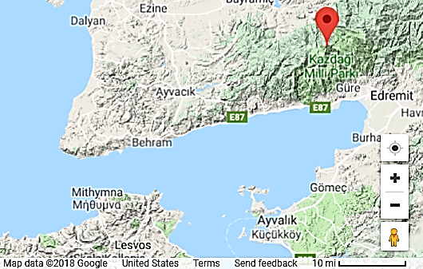

Mount Ida in the Troad, Asia Minor (Turkey). After https://www.google.com/maps/place/Mount+Ida.

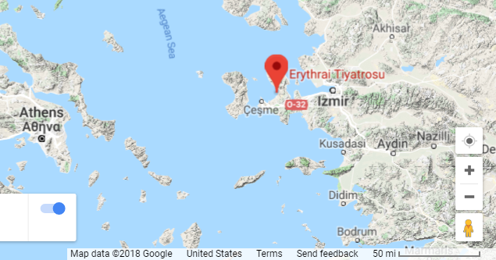 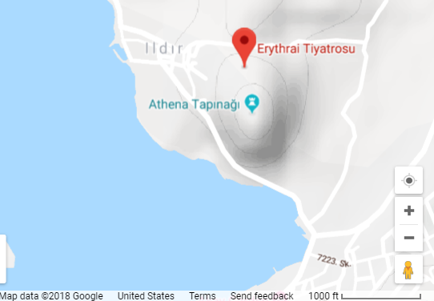

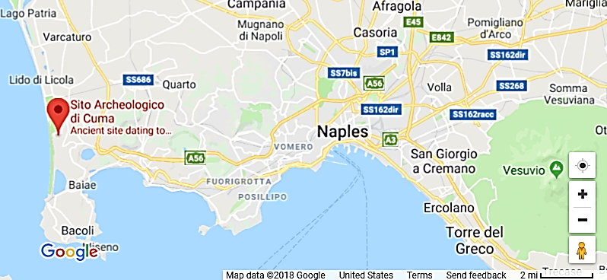

https://www.google.com/maps/place/Erythrai

The Sibyline Books then passed to Erythrae, where they became famous as the oracles of the Erythraean Sibyl in the period of the revered lawmaker Solon (c 638 – c 558 BCE) and the founder of first Persian or Achaemenid Empire, Cyrus the Great (c 600–530 BCE) for whom they provided valuable service. The Books finally found their way to the Cumaean Sibyl and from Cumae (Near Naples) then north to Rome by the early third century BCE.

It was at that time, during an outbreak of the plague in Rome about 239 BCE that a group of Roman Elders was commissioned to consult the Sibylline Books for advice on how to deal with the disease. Aesculapius was cited by the Books as the physician most appropriate. Immediately, the delegation set sail on a Roman trireme from Ostia to the renowned Aesclepieion in Epidaurus, Greece. During the rites of propitiation a large Aesculapian snake left the sanctuary and climbed the ropes of the Roman trireme where it secreted itself. The Roman delegation interpreted this as a signal that the cult was meant to be conveyed to Rome, and when they returned home, ascended the Tiber River and docked at the Tiberine Island, to their amazement the Aesculapian snake debarked the ship thus indicating where the Aesclepieion should be built. Acknowledging this auspicious event, the island was fitted with ashlar of travertine marble in the shape of a huge trireme, with an obelisk in its center resembling a mast in front of the Aesclepieion.

**The two snakes in the first register, therefore, represent an auspicious, apotropaic power: the cavalry men and their horses were being protected by the healing snakes of Aesculapius.**

**SECOND REGISTER.** This apotropaic theme is continued in the second register where the goddess Epona in the center is facing left toward a rayed figure-8 similar to the Cretan figure-8 shields, but his shield is now invested with the power of Sol’s rays. Facing her on the left is a cavalry man on horseback trampling an enemy who is lying prostrate on the ground. Facing her on the right is another cavalry man. Both cavalry men are wearing the Phrygian cap. This cap was used in the Balkans (including Dacia and Pannonia) and Anatolia (including Phrygia).

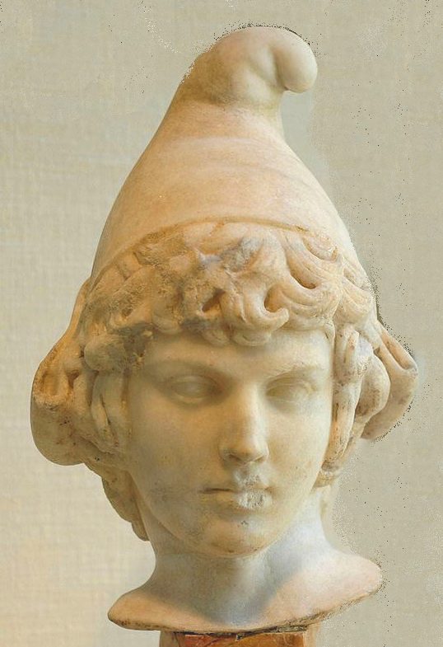 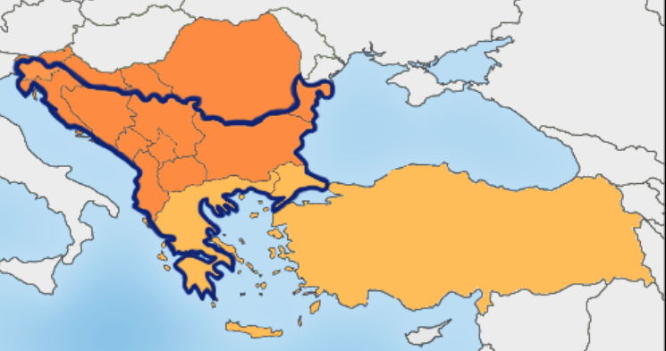

  The Balkan Peninsula using the [Danube](https://en.wikipedia.org/wiki/Danube)–[Sava](https://en.wikipedia.org/wiki/Sava)–[Soča](https://en.wikipedia.org/wiki/So%C4%8Da" \o "Soča) border.  
     Political communities that are primarily included in the Balkan Region.   
     Political communities that are secondarily included in the Balkan Region: Anatolia, Greece, Crete, Boeotia, Thrace, and Macedonia.

Left: Parian marble bust of Attis as a child, wearing the Phrygian cap. **As an adult he was the** mythical consort of the Great Mother (Cybele [i.e. Sibyl]). He was worshipped initially in Phrygia and later throughout the Roman Empire, where he was made a solar deity in the 2nd century CE, probably during the reign of Emperor Hadrian, as this portrait resembles Hadrian’s lover, Antinous, (c 110–130 CE).

Right: The Balkan region according to Prof R. J. Crampton. [CC BY-SA 2.5](https://creativecommons.org/licenses/by-sa/2.5)

The Phrygian cap worn by the two cavalry men may allude to the cap being worn by the Roman military depicted in scenes from the mystery cult of [Mithrais](https://en.wikipedia.org/wiki/Mithraism)m.

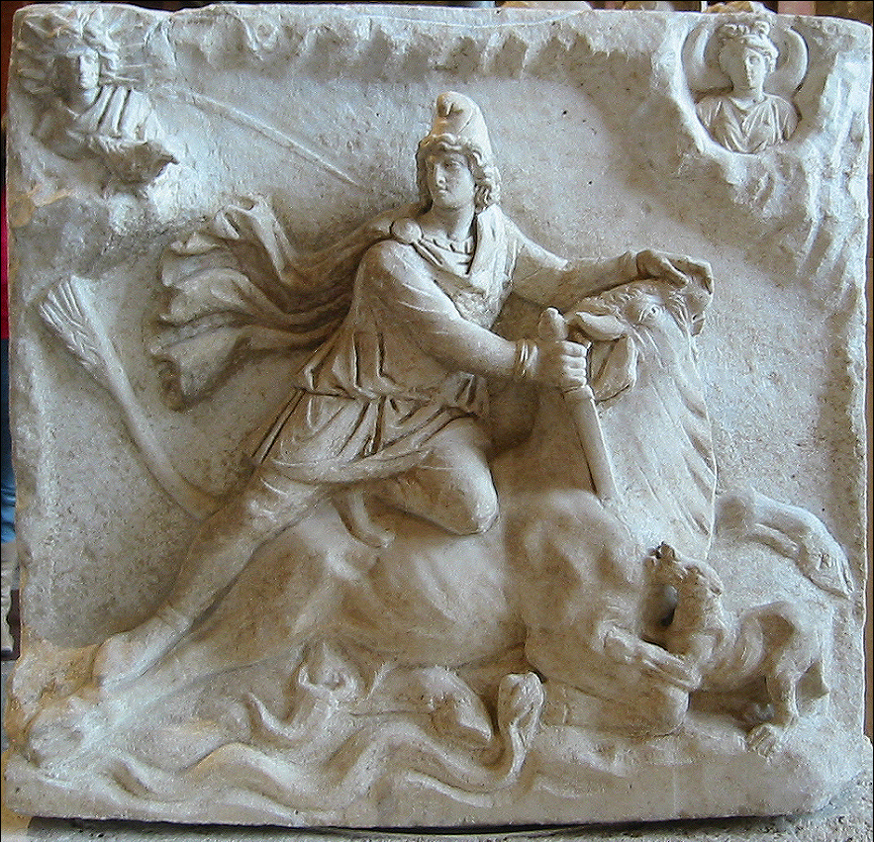 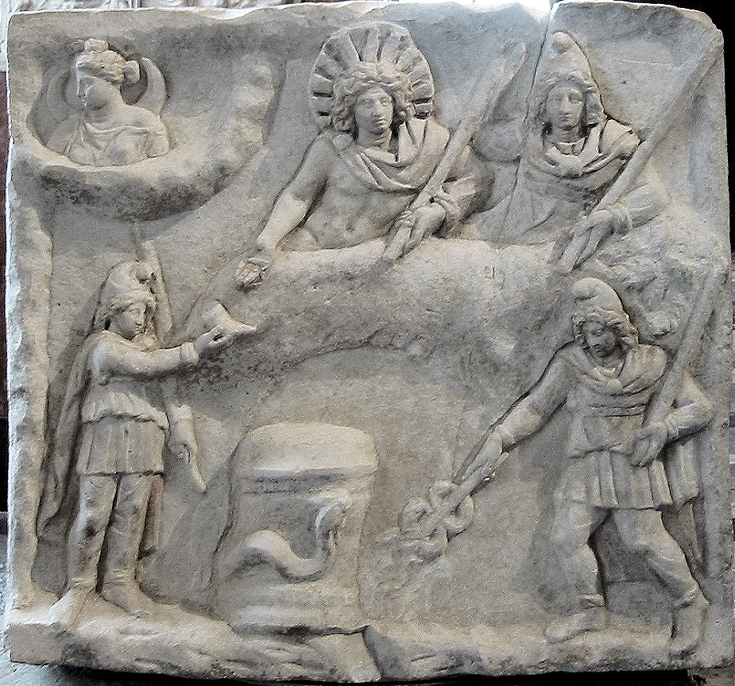

https://upload.wikimedia.org/wikipedia/commons/9/91/Fiano\_Romano\_mithraic\_relief.jpg

[*CIMRM*](https://en.wikipedia.org/wiki/CIMRM) 641: Side A (obverse) of a two-sided Mithraic relief. Found at Fiano Romano, near Rome in 1926 hidden under some modern brickwork. White marble (H. 62cm, W. 67 cm, D. 16 cm) on a travertine base (H. 10cm, W. 76cm, D. 50cm). 2nd-3rd century.  [Louvre](https://commons.wikimedia.org/wiki/Louvre), Department of Greek, Etruscan and Roman Antiquities, Denon wing, ground floor (Ma 3441) This (obverse) face of the monument depicts a tauroctony or bull slaying scene. Mithras, wearing a Phrygian cap, is slaying the bull in a cave, above which in the upper corners [Sol](https://en.wikipedia.org/wiki/Sol_(mythology)) (top left) and [Luna](https://en.wikipedia.org/wiki/Luna_(mythology)) (top right) emerge. Luna has a crescent behind her shoulders. Around Sol's head is a crown of twelve rays, plus a meteor that shoots out in the direction of Mithras that may have significance in terms of his birth.. Also in the upper left is a raven. The dog is at the front haunch of the bull, the scorpion is at the bull’s genitals, the raven is peering down from its perch at Sol’s niche and the snake with a “V”-shaped head is at the front haunch. The tail of the bull ends in ears of wheat. The reverse face of this monument is the banquet scene.

https://upload.wikimedia.org/wikipedia/commons/9/91/Fiano\_Romano\_mithraic\_relief.jpg

Side B (reverse) of a two-sided Mithraic relief. Found at Fiano Romano, near Rome "couché dans un petit réduit de briques" in 1926. White marble (H. 62cm, W. 67 cm, D. 16 cm) on a travertine base (H. 10cm, W. 76cm, D. 50cm). 2nd-3rd century. After <https://commons.wikimedia.org/wiki/File:Mithras_banquet_Louvre_Ma3441.jpg>.

This (reverse) face of the monument depicts a banquet scene. In the middle, a bull's hide, of which the head and one hind leg are visible. Sol and Mithras recline on it side by side. Mithras holds a torch in his left hand and extends his right hand behind Sol. Sol is dressed only in a cape, fastened on his right shoulder with a *fibula*. Around Sol's head is a crown of eleven rays. He holds a whip in his left hand and extends the right towards a torchbearer who offers him a *rhyton*. In the lower right is another torchbearer, with raised torch in his left hand. In his right hand, a *caduceus* (with two snakes) held into the water emerging from the ground. In the middle, an altar in the coils of a crested snake. In the upper left corner, Luna in a cloud, looks to the left. Traces of red paint still adhere to the attire of Sol, Mithras and the torchbearers. The obverse face of this monument is the tauroctony scene.

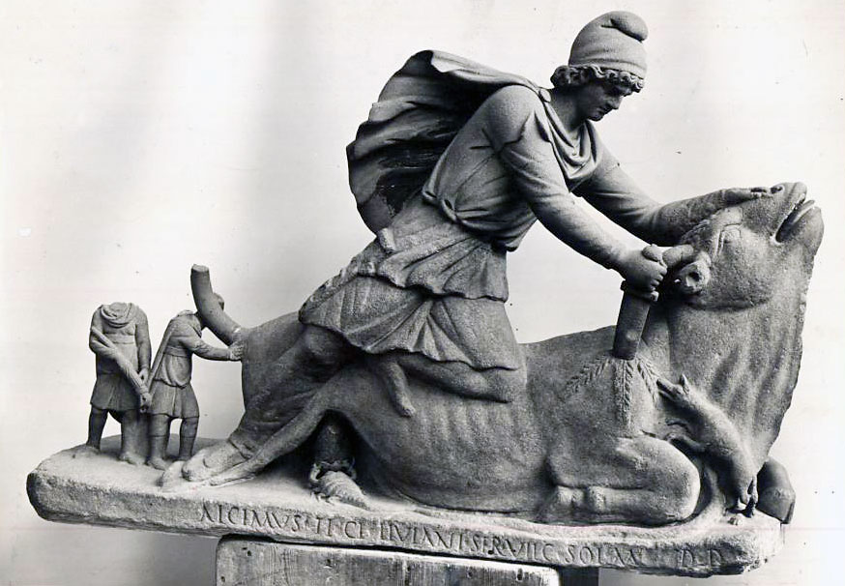

Earliest Mithraic monument in Rome [CIMRM 593](http://www.tertullian.org/rpearse/mithras/display.php?page=cimrm593), c 98-99 CE, a depiction of Mithras killing the bull.

The earliest Mithraic monument is thought to be [CIMRM 593](http://www.tertullian.org/rpearse/mithras/display.php?page=cimrm593), a depiction of Mithras killing the bull, found in Rome. There is no date, but the inscription tells us that it was dedicated by a certain Alcimus, steward of T. Claudius Livianus. Vermaseren and Gordon believe that this Livianus is a certain Livianus who was commander of the Praetorian Guard in 101 CE, which would give an earliest date of 98-99 CE.[6](http://www.tertullian.org/rpearse/mithras/display.php?page=History" \l "note6)

The syncretism of Mithraism with Sol Invictus, the “Unconquered Sun,” a popular theme among the Roman military and one which Constantine I would use is found on [CIMRM 362](http://www.tertullian.org/rpearse/mithras/display.php?page=cimrm362), an altar or block from near SS. Pietro e Marcellino on the Esquiline in Rome was inscribed with a bilingual inscription by an Imperial freedman named T. Flavius Hyginus, probably between 80-100 AD. It is dedicated to *Sol Invictus Mithras*:[7](http://www.tertullian.org/rpearse/mithras/display.php?page=History" \l "note7)

Soli / invicto Mithrae / T(itus) Flavius Aug(usti) lib(ertus) Hyginus / Ephebianus / d(onum) d(edit).

Another example of this syncretism of Mithraism with Sol Invictus is recorded by Kaibel,*ISI*, 996.

Ἡλίῳ Μίθραι / Τ(ίτος) Φλάουιος Ὑγεῖος / διὰ Λολλίου Ρούφου / πατρὸς ἰδίου

Helios Mithrae, Titus Flavius Hyginus, dia Lolliou Rouphou, patros idiou

The syncretism of Mithraism with Asclepius comes from the [Sidon *cippus*](http://www.tertullian.org/rpearse/mithras/display.php?page=supp_Lebanon_Sidon_Cippus) dedicated by Theodotus priest of Mithras to Asclepius, 140-141 AD; This *cippus* was discovered in the temple of Echmoun in Sidon and published by M. Dunand. It bears a Greek inscription, saying that it was dedicated to the holy god Asclepios by Theodotus, ἱερεύς of Mithras in the [Sidon] year 251. The local era of Sidon makes that A.D. 140-141.[1](http://www.tertullian.org/rpearse/mithras/display.php?page=supp_Lebanon_Sidon_Cippus" \l "note1) Also listed in *Supplementum Epigraphicum Graecum*.[2](http://www.tertullian.org/rpearse/mithras/display.php?page=supp_Lebanon_Sidon_Cippus" \l "note2)

*See also*[*CIMRM 74 - the Sidon Mithraeum*](http://www.tertullian.org/rpearse/mithras/display.php?page=cimrm74)*.*

|  |  |
| --- | --- |
| [1](http://www.tertullian.org/rpearse/mithras/display.php?page=supp_Lebanon_Sidon_Cippus" \l "FN1) | Israel Roll, *The mysteries of Mithras in the Roman Orient: the problem of origin*, in: "Journal of Mithraic Studies", Volume II, No. 1, pages 53-68. Reference given is: Dunand, M., *Le temple d'Echmoun a Sidon, Essai de chronologie*, *Bulletin du Musée de Beyrouth* 26, 1973 (appeared in 1975), p.7-25 (plate XIII left). Also mentioned by Roger Beck, *Mithraism since Franz Cumont*, ANRW II, [p.2013](http://books.google.co.uk/books?id=wFceDNFgVowC&lpg=PA2013&ots=MWwU9h3kNo&dq=mithraeum%20sidon&pg=PA2013#v=onepage&q&f=false): "A cippus from Sidon (DUNAND 1973) attests a ἱερεύς of Mithras in A.D. 140/141." |
| [2](http://www.tertullian.org/rpearse/mithras/display.php?page=supp_Lebanon_Sidon_Cippus" \l "FN2) | SEG 55 1661 - Dedication to Theos Hagios Asklepios, 141 A.D. From area of Bostan es-Sheikh, 3 km north of Sidon. |

The earliest military inscription, by C. Sacidius Barbarus, centurion of XV Apollinaris, from the bank of the Danube at Carnuntum, probably before 114 AD.[9](http://www.tertullian.org/rpearse/mithras/display.php?page=History" \l "note9) Richard Gordon, "The date and significance of CIMRM 593 (British Museum, Townley Collection)", *Journal of Mithraic Studies* 2, 1978, p.148-174. Online [here](http://www.hums.canterbury.ac.nz/clas/ejms/out_of_print/JMSv2n2/JMSv2n2Gordon.pdf). p. 150. This is the earliest archaeological evidence outside Rome for the Roman worship of Mithras, a record of Roman soldiers who came from the military garrison at Carnuntum.[10](http://www.tertullian.org/rpearse/mithras/display.php?page=History" \l "note10)

The earliest dateable Mithraeum outside Rome dates from 148 AD.[11](http://www.tertullian.org/rpearse/mithras/display.php?page=History" \l "note11)

The Mithraeum at Caesarea Maritima is the only one in Palestine and the date is inferred.[12](http://www.tertullian.org/rpearse/mithras/display.php?page=History" \l "note12)

Above him is a crescent moon, the symbol of Luna. On either side of her cavalry greet the goddess. The horse on the left step on a fish (on the proper right hand side of the central figure) and a man lying on the ground (on her proper left-hand side).

The third register contains in the middle a couple of men (possibly priests, because on many of these plaques they are depicted boldly), grouped around a table with a fish (which has been explained as offertory meal); there are other figures in the same register.

In the fourth register symbols speak for their powers: a tripod table with fish on it is the object of Resurrection. The four elements indicted by their symbols are controlled by the Rider: Earth as a snake, Air as a rooster, Fire as a Lion and Water as a Kamtharos.

**LC Classification:**

**Date or Time Horizon:** Circa 2nd-4th century C.E.

**Geographical Area:**

**Map:**

**GPS coordinates:**

**Cultural Affiliation:**

**Medium: Lead**

**Dimensions:** 92x77x3mm, rectangular in shape and cast in relief.

**Weight:**

**Condition: original,** Minor damage to left bottom of border, otherwise well preserved.

**Provenance:** Collection of Professor Rudolf Franz Ertl. He published part of his collection of cult plaques in the book Donaureiter – Bleivotivtafeln. Versuch einer Typologie (Wien, 1996). Reinhard Dollinger

45 Great Cumberland Place

W1H7DL Marble Arch, London

Großbritannien

**Discussion:**

The protector of horses, mules, and cavalry, Epona was one of the only non-Roman goddesses to have been wholly adopted by the Roman Empire.  Often depicted astride a horse, Epona resonated in the forces of the Roman cavalry as an inspiration and guide through even the darkest of battles, and she remained one of their most worshipped goddesses between the first and third centuries AD.

Interestingly, Epona was also seen as a goddess of fertility, accompanied in many of her depictions by grain or a cornucopia. Coupled with the worship of her equine prowess in the military, it is evident she was seen both in Gaulish and Roman cultures as a deity of prosperity within the equestrian home and on the battlefield.

It has also been argued that Epona served as an escort for souls into the afterlife. The presence of a statue of Epona in her horse form [**was found in the grave of a young girl**](http://www.huntspost.co.uk/news/the-roman-burial-that-offers-a-rare-glimpse-into-past-of-huntingdonshire-town-1-5301779)who died in the 2nd century and seems to support this notion. That burial was discovered in Godmanchester (Roman Durovigutum), in the Huntingdonshire district of Cambridgeshire, England.

Originally from Gaul, Epona was worshipped in Britain throughout the Iron Age, coming to the continent during the time of the Romans. As far as modern scholarship can tell, her worship extended as far north as the Strathclyde Region in Scotland, with depictions of her found on the Roman wall forts of Hadrian and Antonine, but her veneration stretched no further than the farthest reach of the Empire.  There is no evidence of Epona in the Near East - an understandable lack, as the Romans were never able to conquer or occupy the Persian Empire. It is unknown from where, exactly, Epona originated but she was prevalent throughout the tribes of the Celts and quickly became widespread throughout the Empire as well.

Epona made her way to Rome through the aid of the Roman military. The Roman cavalry was formed of foreign auxiliaries from groups and tribes conquered by the Empire.  Though many of these men were not citizens, citizenship could be attained after a certain number of years in the military, which meant that the Roman forces were exposed to foreign religions quite often and for long periods of time.  Even though Gauls were not one of the prominent groups in the cavalry, Epona was introduced to this amalgamation of men during their time fighting in Gaul. With so many men from so many different cultures gathered together with such a prestigious equestrian duty to perform, it is natural that they would desire their own religious spirit or guide. Upon discovering her impression in Gaul, Epona became the perfect choice.

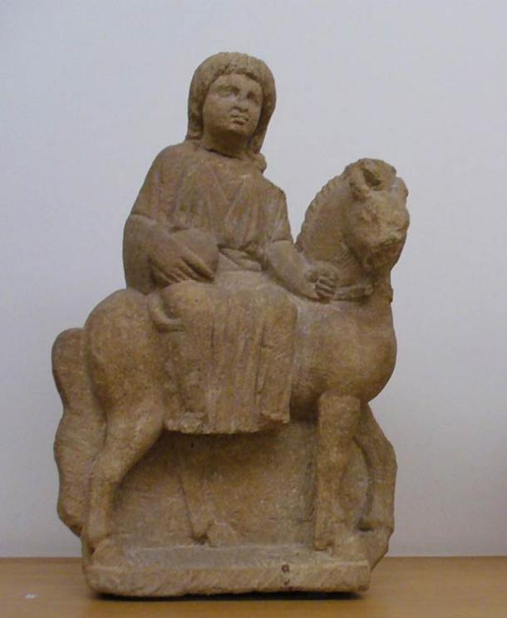

Small sculpture of the Roman/Celtic goddess Epona, third century CE. [**Public Domain**](https://commons.wikimedia.org/wiki/File:Luxembourg_MNHA_265_Epona_provenance_incertaine.jpg)

Epona was one of the gods of the Augustus Equites singulares, who were recruited among cavalry units located in the regions on the Rhine and the Danube. Epona's distribution throughout the realm was greatly aided by the fact that the Romans were already a religiously tolerant culture. Many gods of Gaul had been brought into the Empire by marrying Roman gods (as was the case with Mercury and Rosmerta) or by re-appropriating their names and affiliations to align with pre-existing Roman gods.

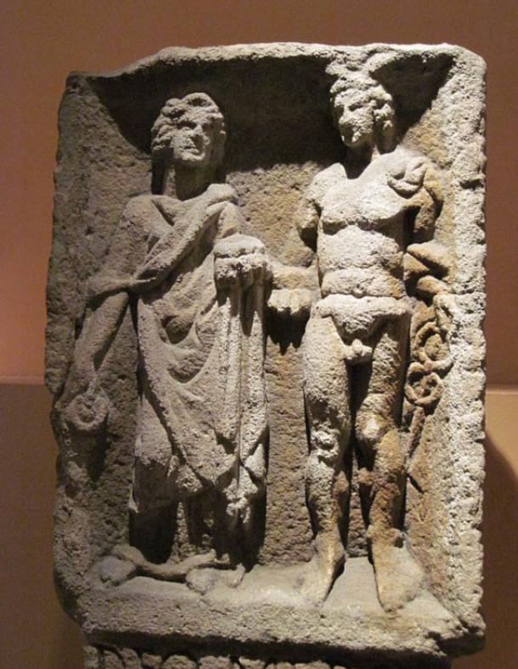

Relief of Mercury and Rosmerta from Eisenberg in present-day Rhineland-Palatinate. Wikimedia, ( **[CC BY-SA 3.0)](https://commons.wikimedia.org/wiki/File:Mercurius_Rosmerta_HistMusPfalz_3513.jpg" \t "_blank)**

Epona is unique in that she was not renamed or married to a Roman husband—she came to Rome as herself and blended quite smoothly into the Roman military.  She is the only known Celtic deity to have been embraced in her original form by the Empire, with little adjustment made to her list of attributes. Her likeability spread outside of the military and into the homes of the Roman people as well.

The countryside of Rome consisted of widespread farmland, an environment that led to a need for a goddess who could protect and look over the stables and horses of the common people outside of the military.  As Epona was introduced into the city of Rome, her name and image spread like wildfire. Farmers, stable hands, grooms, drivers, and so many other ordinary people who interacted with horses and mules on a day to day basis welcomed Epona into their own lives and homes, and worshipped her as frequently as the Roman military She was revered in various ways throughout the region, depending on whether the worshipper was military or civilian. The cavalry erected small shrines wherever they went, which was one of the reasons why her cult was so widespread.  They sacrificed to her before important battles and wrote numerous vows and inscriptions to her.

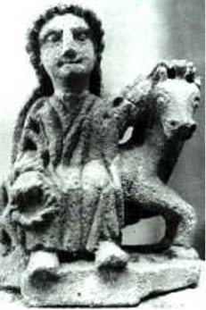

Small Epona sculpture from Auxois, France. [**Public Domain**](https://commons.wikimedia.org/wiki/File:Epona_Auxois.jpg)

In the home, there were more diminutive devices for her worship—tokens and flowers were laid out to her in countless equine locations, and small statues were often erected in houses and stables. It was on these statues that cornucopias were depicted, revealing the desire of the Roman people for her to bring fertility to their stables and strong mares to their herds. A good horse or donkey was an important source of transportation in ancient Rome—among the elite in particular, a strong horse was a valuable source of prestige.

Statues depicted Epona in three varying forms: astride her horse, as an imperial goddess, or riding upon a cart. It should be noted that in the Gaulish tradition, it was not customary to portray the gods in human form but rather in the form of an animal, plant, or other appropriate emblem of their worship.  Previous to the Romans, Epona was merely the image of a horse or mule. Upon coming to Rome, she was altered to appear as the Roman gods did, thus in the three aforementioned ways.

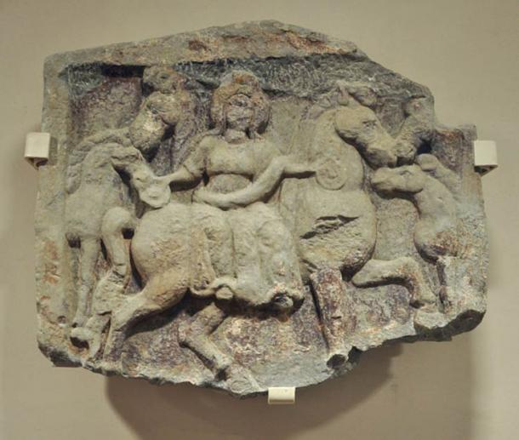

A relief depicting Epona and horses. Vorarlberg Museum, Bregenz, Austria. [**Public Domain**](https://commons.wikimedia.org/wiki/File:Epona-Relief_VLM.jpg)

Riding was the most common way in which Epona was shown, always sidesaddle and often with a cornucopia in her hands signifying both her fertility and that of the horses under her guidance. The imperial image portrays Epona in a more regal fashion, often standing between two to four horses and either standing or seated on a throne. Images such as these were undoubtedly inspired by the art of the Roman emperor and meant to show Epona as the sovereign of both equestrians and their owners.  The cart image has the least circulation and it shows Epona in a cart or chariot lead by horses. Interestingly, these images can be seen as a servile relationship between the goddess and her creatures which may (though there is little evidence) be the reason such depictions are few and far between.

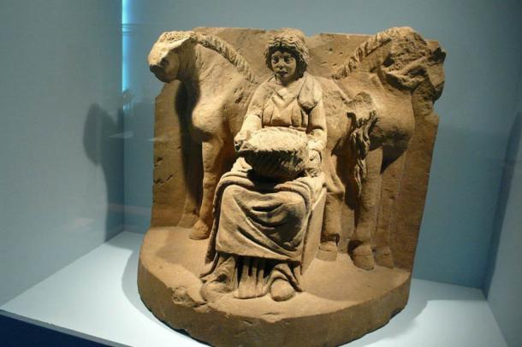

The motif of the "Lady of the Animals" lives on this religious depiction. Flanked by two horses, Epona is shown sitting on a throne holding a fruit pie on her lap. Circa 200 CE.. Wikimedia, ([**CC BY-SA 2.0**](https://commons.wikimedia.org/wiki/Category:Epona#mediaviewer/File:Epona.jpg))

Epona is easily one of the most interesting goddesses assimilated into the Roman Empire. The apparent seamlessness and ease of her transition is only one of the reasons why she was such a fascinating addition to the culture of the Romans. She remains an example of the ways in which foreign gods were adopted into the Empire and the reasons for these adoptions. Furthermore, her fusion into the Empire allowed for rare extensive knowledge of her original Gaulish character and her subsequent alterations to be passed down for modern research.

Featured image: A relief of Epona, flanked by two pairs of horses, from Roman Macedonia, foruth century C.E. Wikimedia, ([**CC BY-SA 3.0**](https://commons.wikimedia.org/wiki/File:Epona_Salonica601_ArchMus.jpg))

By [**Ryan Stone**](https://www.ancient-origins.net/users/ryan-stone)

**References:**

Adkins, L. and R. Adkins.1998.  Handbook to life in ancient R Rome. Oxford: Oxford University Press.

Anon. 2015. "Epona Depictions." Epona.net- a Scholarly Resource. January 1, 2004. Accessed January 1, 2015. [**http://www.epona.net/depictions.html**](http://www.epona.net/depictions.html).

Bianconi, G. L. 1789. Descrizione dei Circhi particolarmente di quello di Caracalla e dei giuochi in essi celebrati. Roma: Pagliarini.

Cattaneo, G. 1819). Equejade, monumento antico de bronzo del Museo nazionale ungherese considerato ne' suoi rapporti coll' antichità figurata. Milano, Imp. Regia stamperia. Fig. 3

Chevallier, Raymond. 1998) *Voyages et Déplacements dans l'Empire Romain*. Armand Collin, Paris.

Collingwood, R.G.; Wright, R.P. 1965. The Roman Inscriptions of Britain (RIB) Oxford: Clarendon Press.

Dorow, W. 1826. *Opferstätten und Grabhügel der Germanen und Römer am Rhein*. Wiesbaden, **II**, p.28 and plate XIV.

Edelstein, Ludwig and Emma Edelstein. 1998. *Asclepius: a Collection and Interpretation of the Testimonies*. Vol. 2. Baltimore: Johns Hopkins Press.

Ertl. Rudolf Franz. 1996. Donaureiter – Bleivotivtafeln. Versuch einer Typologie. Wien.

Espérandieu, É. 1907. Recueil général des bas-reliefs de la Gaule romaine. Paris, Imprimerie nationale.

Hettner, F. 1876. *Katalog des Königlich-Rheinischen Museums Vaterländischer Alterthümer bei der Universität Bonn*. Bonn, p.79, #216

Irby-Massie, G. L. 1999. Military religion in Roman Britain. Leiden: Brill.

Joffroy, R. 1978. Découverte d'une cachette de bronzes gallo-romains à Champoulet (Loiret). Comptes rendus de l'académie des inscriptions et belles-lettres, Paris(CRAI): 795-806.

Karapanou S. 1999. *The Bath of Ancient Trikki. Health and cleanliness in ancient Greece.* Athens: MELINA-The World of Antiquity.

Kastriotis P. 1903. *Excavations in Thessaly.* Athens: The Trikki Asclepeion.

Linduff, Katheryn. 1979. Epona: A Celt among Romans. Brussels: Latomus.

Magnen, René; Thévenot, Emile. 1953. *Épona: déesse Gauloise des chevaux, protectrice des cavaliers*. Bordeaux: Delmas,

Mitchell-Boyask, Robin. 2008. *Plague and the Athenian Imagination: Drama, History and the Cult of Asclepius*. Cambridge: Cambridge University Press.

Reinach, Salomon. 1895, 1898, 1899, 1902, 1903. *Épona*. *Revue archéologique,* 1895, part 1, 113, 309. Addenda *ibid*. 1898, part 2, 187; 1899, part 2, 61; 1902, part 1, 227; 1903, part 2, 348.

Schleiermacher, W. 1933. *Studien an Göttertypen der römischen Rheinprovinzen*. **23**. Bericht der Römisch-Germanischen Kommission.

Speidel, M. P. 1994. Riding for Caesar: the Roman Emperors' Horse Guards. Cambridge: Harvard University Press.

Szilágyi János György. 2001*. Antik művészet - vezető az Antik Gyűjtemény állandó kiállításához*, Budapest: Szápművészeti Múzeum.

Tziafalia A. 1998. “Asclepeion of Trikki: Myth or Reality”, *Trikalina* 8, 171-218/

Wickkiser, Bronwen. 2008. *Asklepios, Medicine, and the Politics of Healing in Fifth-century Greece: Between Craft and Cult*. Baltimore: JHU Press.

Woolf, G. 1998. Becoming Roman: the origins of provincial civilization in Gaul. Cambridge: Cambridge University Press.

**APPENDIX**

Traditionally, it was in Thrace that fiery Ares was conceived, and likewise his antithesis, the watery charmer of beasts, Orpheus.  From the sixth century BCE onwards, his Egyptian-oriented Orphic cult propogated a universal following throughout the ancient world.   Even earlier, Thrace had hosted the arrival of a heated Phoenician Bull, Dionysos, who not only came to share Apollo's abode at Parnassus but who played an essential role in the Eleusinian rites of Demeter.  Far from being a barbarian backwater therefore, the Danubian realms seems to have fostered a spiritual plurality in which local traditions were freely supplemented from international sources.

Modern Bulgaria largely equates with the ancient territory known specifically as Thrace.   Since its easterly limits flanked the Pontic Sea and reached down to the Bosporus, it was an open door to the East.  Through it the concepts of the Levant and ancient cultures far beyond flowed north of Greece into Danubia, Macedonia and the Balkan territories of Moesia and Illyricum.   At the same time Thrace maintained close links with Athens to allow a permeation from the south of Cretan, Phoenician and Egyptian influences.  During the fourth century B.C. the Macedonians conquered territories south of the Danube, including Thrace, later the springboard for Alexander's invasion of Asia.   Macedonian kings, the Ptolemys, then subsequently ruled Egypt.

There had been major cultural upheavals much earlier, however.  During the second millennium B.C. the Indo-European migrations began to flow west and east from Eastern Europe and the Pontic Steppes.   These included Aryans, who colonized western India as far as the Indus Valley.  The migrations also engulfed parts of Anatolia including the territory of the Mitanni, a number of whose rulers bore Indo-European names.  In 1380 B.C. the Mitanni concluded a treaty with the neighboring Hittite king which cited the names of their principal gods, who included twins known as the 'Nasatyas'.   This epithet also attached to deities of their Aryan counterparts, who appeared in Vedic Indian legends as the 'Asvins', twin horsemen born of the Dawn and the Sun.   It seems probable therefore that the migrants transplanted this concept of 'twin Horsemen of the Sun' from a Bronze Age icon originally rooted in the eastern Danubian region.

 Twin equestrians certainly appear on the plaques, hence their assignment to some hypothesized 'Danubian Horsemen' cult.  Over a very long period therefore, 'Danubians' would have been subject to numerous external influences emanating from the fringes of Persia, Greek communities along the Black Sea coast, sea-traders from the Aegean, overland traders from Western Europe and Attica, and conquests by Celts, Macedonians and Romans.

**

|  |
| --- |
| *http://www.collector-antiquities.com/clear.gif* |
| *http://www.collector-antiquities.com/typo3temp/pics/72f307d13d.jpg* |
| Found at Cioroiu Nou in Romania. |

Having overviewed the cultural development of the region, it is now time to cut to the chase regarding the plaques specifically.  Despite their potential ancient links, a pre-occupation with 'Horsemen' epithets may be totally misdirected.   That riders featured on the plaques is no proof the cult which incorporated them was by nature equestrian, or indeed that its adherents bore any relation to the original indigenous tribes in whose areas such plaques are now found.

The plaques were not manufactured until Illyricum, Moesia and Thrace had been taken under the umbrella of the Roman Empire.  From the beginning of the first century A.D. the regions along the Danube were once again subject to much upheaval.   Emperors and their armies, from Tiberius onwards, campaigned there.  At one stage as many as twelve Roman legions were stationed along the river limits. From whence their contingents were gathered, particularly perhaps cavalry units, may well have impacted on the development of any Danubian cult.  Likewise settlers in the newly established frontier towns were drawn from many quarters, bringing together wide-ranging religious concepts.

Somewhat conclusively perhaps, when the Romans embraced the Danube lands, although busts of their emperors were stamped upon the coinage, the legendes retained a Greek form and the reverse types exhibited Greek rather than Roman iconography.  Clearly, therefore, when the plaques were manufactured, traditional Greek concepts and symbologies had long been the established lingua-franca in "Danubia".

Logic would suggest then that the symbols incorporated in the plaques would also emulate Greek origins.   From where else could they have derived?   There is no evidence of any early literary tradition in the Danube area.  Although some Greek poets linked the Hyperboreans

|  |
| --- |
| *http://www.collector-antiquities.com/typo3temp/pics/37dedc57a5.jpg* |

Epona is in the center of this circular lead votive piece wearing a pleated kilt and standing between Luna and her crescent Moon on the left and Sol with his crown of 5 rays on the right. She is holding the reins of two horses with riders. The horse on the left has a mane with 6 spikes. The riders appear to be wearing the traditional Legionnaire’s kilt with perhaps a cuirass above.

Directly below Epona is a fish lying on a tripod table with animal-shaped legs. on either side of which are two individuals bent over in obeisance.

**IDENTIFYING THE PLAQUE'S CHARACTERS.**

Having surveyed the cultural and religious background of the region and noted that the plaques were the work of a Latinised cult operating widely along the Danube and across the Balkans, some attempt can be made to identify the icons portrayed.   The common identifying theme on virtually every plaque, is a goddess standing between two confronted equestrians.   Most often she is portrayed gripping their reins. She may also have between her hands, not reins, but what appears to be a rope.  Elsewhere, she may be represented with her hands raising the folds of her robe across her front to form a kind of cradle.

In ancient Greece such a cradle would have substituted for a **liknos**, or grain basket.   Women who sewed corn in the fields used their gown in this way to carry the grain they scattered.   In another context, a young child could be carried in such a makeshift crib, as Brimo was carried by Demeter in the ceremonies at Eleusis.   So why did this central figure adopt a varied pose?   The answer lies in the adherents to the cult.   With so many varieties of plaque being produced locally over such a wide area, there were bound to be preferences in the manner of portraying the objects of worship.   A study of these variations is the key to revealing the central themes.

Let us, for the moment, consider what the horse riders themselves represent.   Many plaques place identifiers above them.  In some instances this may be a star above one and a crescent above the other.  Similarly, a bust of the Sun and a bust of the Moon may be emphatically placed above.   The inference is clear.  As in coins that place a crescent moon on the head of a female deity, it is there to indicate that the deity is a moon goddess.   Why would plaque iconography differ?    What the plaque maker is indicating is that one rider is the Sun and the other, its twin, the Moon.   In a classical setting that would usually be Apollo and Artemis.  They are twin lights and they are being grasped together in the hands of the central goddess.   So who is this deity, grasping twin lights in her hands?

There are really only two candidates, frequently portrayed holding light bearing, flaming torches; Artemis and Demeter.   Artemis can be disregarded because, as the Moon, she is already present on one twin horse.   Demeter however, has a long history of association with horses.   She began as a horse goddess and, as a mare, she was raped by Poseidon.   In her Phygalion cavern she was portrayed wearing a horse's head.   More tellingly, the portrayal of her robe as a corn bearing **lyknos** and cradle, immediately places her into the camp of an agrarian goddess and potential mother.   That latter aspect would eliminate Athena.

That one of the equestrians should transpire to be Apollo, need raise no great surprise.   If it is considered that the coinage of the Celtic nations was based on the Macedonian model, from the Crimea to Britain and down to the south of Spain, it bore a common obverse portrayal of the head of Apollo, and on the reverse was a horseman, generally also regarded as Apollo.   Added to that is the equally abundant iconic Celtic horseman, the little bronze figurine who sits on a crude horse with his right hand raised in a salute, just like the one on the plaques.   They are also found right across the Celtic world and were current well into the Roman period.

The plaque horseriders are often shown holding snakes aloft on the tips of their spears (as illustrated below) and twin snakes are virtually always portrayed on the plaques.   Apollo was from his earliest months a renowned snake slayer and later closely associated with the Pythonic oracles at Delphi.   Snakes were also used in the Balkans in a similar prophetic way, as Aelian recorded  (**Animalia- XI. 2**)

"The people of Epirus and all strangers sojourning there, besides any other sacrifice to Apollo, on one day in the year hold their chief festival in his honour with solemnity and great pomp.   There is a grove dedicated to the god, and round about it a precinct, and in the enclosure are serpents, and these self same serpents are the pets of the god.   Now the priestess, who is a virgin, enters unaccompanied, bringing food for the serpents.  And the people of Epirus maintain that the serpents are sprung from the Python at Delphi.   If, as the priestess approaches, the serpents look  graciously upon her and take the food with eagerness, it is agreed that they are indicating a year of prosperity and of freedom from sickness.  If however, they scare her and refuse the pleasant food she offers, then the serpents are foretelling the reverse of the above, and that is what the people of Epirus expect."

|  |  |
| --- | --- |
| |  | | --- | | *http://www.collector-antiquities.com/uploads/pics/pic_plaques.JPG* | |

|  |  |
| --- | --- |
|  | *http://www.collector-antiquities.com/uploads/pics/scammmmmmmmmmmmm.JPG* |

.

That the plaques are not after all purely Celtic but portray deities common to the Greco-Roman communities in which they were made, would explain why no written record of a "Danubian Horseman" cult has survived, or why no edifice specifically dedicated to them has ever been found.  In the tolerant ancient world any religion was open to any genuine pursuer of the truth and although cult members may have had their own personal adherences, nevertheless they were free to blend with other devotees.   Apollo as the god of intellectual light, symbolised by the Sun, was universally acclaimed and places for his worship already abounded.  There was no need to create more.

**From antoninus.**

12th April '10.

A feature often given central significance was the fish on an offering table, or ara sacra, placed immediately before the goddess.   The table is of interest because of its shape.   It replicates the pattern of the mythical tables made by Hephaestos for his wedding with Aphrodite.   They had three leonine legs but were generally regarded as sun wheels.  In Roman parlance, Hephaestos equated to Vulcan, the lame smithy god who employed the searing heat of flaming Vesuvius and Aetna to transform substances.

Pompeius Festus, in his Epitome of "De Verborum Significatu", written more or less contemporaneously with plaque production, recorded that King Numa skilfully brought about the abandonment of human sacrifice to Vulcan by replacing the human with a fish.   The odour of the fish burning in the sacrificial flames was sufficient to appease the God.   Ovid (Fasti) and Plutarch (Lives - Numa), both commented that the same king similarly replaced human sacrifice to Zeus with "pilchards", onions and hair.  Therefore, the plaque icon, of a fish placed on a sun-wheel ara, may have had a considerable significance, perhaps hinting at a sacrificial ceremony, and almost certainly designed as a double-entendre.

On a very rare, privately owned plaque, now located in Germany, a Latin inscription appears across the upper fields  -  the phrase " DAP  IMVS".   In these inscriptions, the last letters of the participles have been reoriented.  The 'P' has been reversed and the final 'S' has been rotated.

All the usual ritual objects are present, a lion, a cockerel, a twin handled wine cup.   These represent the ancient three seasons of the year.   The snakes encompass the goddess with eternity and the equestrians flanking her are NOT the Dioscuri as some believe, but the Sun and Moon - Apollo and Artemis.  ( This comes from a study of later plaques.)  As I mentioned, these early plaques gave little away!!   In my view the earlier types could have predated their successors by as much as a century and might be dated to the end of the first century.